Multimodal Wearable Stress Detection Using Deep Learning: A Comparative Study of Signal Analysis and Real-Time Monitoring
Praneet Raj (25BCE2280), Aarav Shukla (25BCE0707), Saanvy Panda (25BCE2180)
Project Guide: Dr. Vivek Rajpoot | Department of Communication Engineering
School of Computer Science and Engineering, Vellore Institute of Technology (VIT), Vellore, India
2. Abstract & Keywords
Stress is a multi-faceted psychophysiological state governed by the complex interplay between the sympathetic and parasympathetic branches of the Autonomic Nervous System (ANS). While traditional wearable stress detection approaches rely on isolated unimodal streams or handcrafted features evaluated under random train-test splits, they systematically suffer from cross-subject baseline drift and fail to model dynamic cross-channel physiological coupling. Building upon the foundational design established in Review 1, this project delivers the complete implementation, optimization, and empirical evaluation of an end-to-end multimodal stress detection framework evaluated against the benchmark Wearable Stress and Affect Detection (WESAD) dataset. We extract, temporally calibrate, and filter three physical sensor streams—AD8232 single-lead ECG, MAX30102 PPG, and DS18B20 skin temperature—resampled to a synchronized 128 Hz timebase and segmented into 22,192 three-second sliding windows across 15 subjects.
We systematically evaluate seven distinct architectures across both deep learning and classical paradigms: 1D-CNN, Bidirectional LSTM, Temporal Transformer, Spatio-Temporal Graph Convolutional Network (ST-GCN), Random Forest, Support Vector Machines (SVM), and XGBoost, utilizing a strict 15-fold Leave-One-Subject-Out Cross-Validation (LOSO-CV) protocol to guarantee zero data leakage across subjects. Our proposed ST-GCN models the human body as a dynamic graph topology where edge weights are formulated via per-window Pearson cross-correlation matrices between cardiac (ECG/PPG) and thermal biosignals. ST-GCN achieves champion deep learning performance with 76.50% ± 16.5% accuracy, an F1-score of 0.6578 ± 0.216, and an AUC-ROC of 0.8665 ± 0.135, while executing single-window inference in 2.57 ± 1.51 ms on CPU—comfortably satisfying the hard < 50 ms real-time requirement for ESP32 microcontroller packet streaming. Finally, the champion model is exported to an ultra-lightweight 73.8 KB ONNX binary, validated with a numerical output deviation of only 4.768 x 10^-6 against native PyTorch, and packaged into a standalone inference engine operating without PyTorch runtime dependencies.
Keywords: Wearable Stress Detection, Multimodal Physiological Signal Fusion, Spatio-Temporal Graph Convolutional Networks (ST-GCN), Leave-One-Subject-Out (LOSO) Cross-Validation, Autonomic Nervous System, Edge AI Deployment, Photoplethysmography (PPG), Electrocardiogram (ECG).
3. Introduction
3.1 Background and Motivation
Mental stress represents a major public health challenge in modern society, contributing significantly to cardiovascular disease, clinical depression, cognitive exhaustion, and occupational burnout. Traditional clinical assessments depend heavily on retrospective, subjective self-report questionnaires (e.g., Perceived Stress Scale, NASA-TLX), which suffer from recall bias, cannot capture momentary psychophysiological shifts, and lack real-time intervention capability. Consequently, continuous, objective, and unobtrusive physiological stress monitoring using wearable embedded devices has emerged as a crucial area of biomedical research.
Physiological stress is mediated by the autonomic nervous system: sympathetic activation initiates the 'fight-or-flight' response, triggering tachycardia (rapid heart rate), peripheral vasoconstriction (reduced peripheral blood flow), and altered thermoregulation. These phenomena manifest across distinct bio-signals: electrocardiograms (ECG) capture cardiac electrophysiology; photoplethysmograms (PPG) measure optical arterial blood volume pulses; and skin temperature probes detect peripheral micro-vascular perfusion changes. Fusing these modalities offers a comprehensive view of autonomic state.
3.2 Real-World Importance of the Problem
Continuous real-time stress detection holds vital transformative potential across multiple domains, including workplace safety in high-stress occupations (air-traffic controllers, surgical staff, industrial operators), academic monitoring for student mental health, and remote telemedicine. Wearable stress monitors empower individuals to identify hidden autonomic distress before clinical decompensation occurs. However, because physiological reactivity varies drastically between individuals—where one person's stressed heart rate is another person's resting baseline—systems must be designed and verified under strict subject-independent protocols.
3.3 Why Arduino/ESP32 + Machine Learning is a Suitable Approach
Deploying machine learning models on low-power microcontrollers such as the ESP32-S3 bridges the gap between bulky clinical instrumentation and wearable consumer wellness devices. The ESP32-S3 architecture combines a dual-core Xtensa LX7 processor operating at 240 MHz, hardware vector extensions, low quiescent sleep modes, native 2.4 GHz Wi-Fi, and Bluetooth 5.0 (BLE) subsystems. When paired with compact, energy-efficient biosensors (AD8232, MAX30102, DS18B20), the microcontroller reliably executes deterministic 128 Hz hardware sampling, edge buffering, and real-time telemetry streaming.
By exporting trained neural representations to ultra-compact Open Neural Network Exchange (ONNX) binaries, edge telemetry gateways (or local companion gateways) can execute complex inference in under 3 milliseconds on standard CPUs without relying on cloud computation or heavy server frameworks. This ensures complete patient data privacy, zero dependence on continuous internet connectivity, and immediate responsiveness.
3.4 Scope of the Project
The primary scope of this project encompasses the design, hardware interfacing, signal conditioning, machine learning formulation, cross-subject empirical validation, and edge deployment of a multimodal wearable stress monitor. The pipeline ingests synchronized Lead-I ECG, optical PPG, and skin temperature biosignals.
Optical Camera Decoupling Rationale: In our initial conceptual proposal (Review 1), optical facial action coding was surveyed as an exploratory parameter. However, during our physical engineering and trade-off analysis, facial video capture was deliberately decoupled from the wearable prototype for three decisive medical and technical reasons:
1. Privacy and Unobtrusive 24/7 Wearability: Wearable stress monitoring must function continuously in private living, resting, and working environments. Continuous optical camera surveillance violates user privacy (GDPR / HIPAA) and is socially unacceptable for continuous wear.
2. Involuntary Autonomic Truth vs. Masked Facial Expressions: Facial expressions can be voluntarily masked or distorted by posture, speech, and lighting variations. In contrast, autonomic biosignals (ECG R-R intervals, PPG pulse transit times, peripheral vasoconstrictive temperature drops) are completely involuntary autonomic nervous system responses that cannot be masked.
3. Embedded Power and Bandwidth Constraints: Real-time video encoding rapidly exhausts ESP32 memory and depletes an 18650 Li-ion battery in under 1.5 hours, whereas our optimized biosensor configuration delivers over 18 hours of continuous autonomous operation with sub-3 ms edge inference.
4. Literature Survey
We conducted a critical review of recent landmark works in wearable physiological stress detection, benchmarking architectures, modalities, validation strategies, and deployment bottlenecks:
Study / Reference | Type | Modalities | Architecture | Reported Metric | Critical Research Gap
Gedam et al. (Nature Scientific Reports, 2023) | Base Paper | ECG, GSR, Skin Temp | Random Forest, XGBoost, ANN | 99.4% (Self-generated) | Evaluated solely on random splits on a self-collected 200-student dataset; lacks subject-independent (LOSO) cross-validation and does not model cross-channel temporal correlation.
Schmidt et al. (ACM ICMI, 2018) | WESAD Creator | Chest ECG/EMG/EDA/Temp, Wrist PPG | Random Forest, Decision Tree, LDA | 80.3% (LOSO) | Established the gold-standard WESAD benchmark. Relied exclusively on static statistical window features; did not investigate deep spatio-temporal representations.
Kim et al. (IEEE JBHI, 2024) | Shuffled ECA-Net | ECG, Respiration, EGG | 1D-CNN + Shuffled Channel Attention | 91.6% (Intra-subject) | Demonstrated high intra-subject accuracy but suffered severe cross-subject performance collapse under unseen subject testing; high computational weight.
Yildiz & Subasi (Biom. Sig. Proc., 2024) | PAMG-AT | Chest & Wrist WESAD (ECG, EDA, Temp) | Hierarchical Graph Attention Network | 94.6% (Chest-only) | Employed over 4 million trainable parameters, creating severe computational latency that prohibits edge microcontroller deployment.
Xiang et al. (Front. Physiol., 2025) | MMFD-SD | Multi-channel ECG/PPG/GSR | Time-Frequency DWT + 2D-CNN | 86.2% (k-fold) | Achieved strong multimodal fusion but relied on computationally heavy 2D Wavelet spectrogram transformations requiring high-power GPU acceleration.
Kyrou et al. (IEEE TAFFC, 2025) | Survey | Wearable Biosignals | Comprehensive DL Survey | N/A (Survey) | Concluded that >85% of published works commit data leakage via random k-fold splits and emphasized the urgent clinical need for strict LOSO validation and edge ONNX deployment.

4.1 Critical Research Gaps Identified
- 1. Subject Identity Leakage: The vast majority of published studies employ random k-fold splits on overlapping temporal windows, allowing windows from the same individual into both training and testing folds, artificially inflating accuracy scores that collapse in clinical deployment.
- 2. Static Feature Engineering Bottlenecks: Classical models mandate computing window-wide FFT power spectrum integrals and Pan-Tompkins peak detectors upstream, introducing computational latency before classification.
- 3. Neglect of Dynamic Cross-Channel Coupling: Traditional deep neural networks treat multimodal channels as isolated 1D streams, completely failing to model how sympathetic activation dynamically alters the cross-correlation between cardiac contraction and peripheral skin temperature.
- 4. Excessive Edge Footprints: Complex attention models exceed edge memory budgets, demanding lightweight, PyTorch-independent ONNX deployment.
5. Problem Statement & Objectives
To accurately, objectively, and continuously detect acute mental stress in unseen individuals using an energy-efficient, low-cost wearable system, while overcoming cross-subject physiological baseline drift, noise contamination, and computational latency constraints.
5.1 Specific Technical Objectives
- Objective 1: Multimodal Ingestion Pipeline: Ingest, filter, and calibrate Lead-I ECG, optical PPG, and skin temperature signals from raw archives into synchronized 128 Hz sliding windows.
- Objective 2: Signal Conditioning Cascade: Apply digital 50 Hz IIR notch filtering, Butterworth bandpass filtering, and subject-wise z-score normalization to ensure clean biosignal tensors.
- Objective 3: Spatio-Temporal Graph Neural Modeling: Formulate a vectorized Spatio-Temporal Graph Convolutional Network (ST-GCN) that constructs dynamic Pearson correlation adjacency matrices per 3-second window.
- Objective 4: Strict Person-Independent Validation: Benchmark seven distinct architectures across all 15 subjects of the WESAD dataset under 15-fold Leave-One-Subject-Out (LOSO) cross-validation to guarantee zero subject identity leakage.
- Objective 5: Real-Time Latency Verification: Achieve single-window CPU inference latency well below the hard 50 ms budget required for real-time ESP32 telemetry streaming.
- Objective 6: Compact Edge Model Export: Export the champion ST-GCN model to a lightweight ONNX binary (73.8 KB) and numerically verify output equivalence with native PyTorch.
- Objective 7: End-to-End System Integration: Construct complete ESP32-S3 firmware and a live real-time browser dashboard capable of streaming live biosignal telemetry and classifying stress instantaneously.
6. System Architecture & Block Diagram
The overall system follows an end-to-end edge-to-telemedicine architecture designed for continuous, low-latency monitoring. As depicted in Figure 1, the architecture comprises five synchronized functional stages:
- Stage 1: Hardware Sensing Layer: ESP32-S3 microcontroller synchronously samples AD8232 (Lead-I ECG at 128 Hz via ADC1), MAX30102 (Red/IR PPG at 128 Hz via I2C), and DS18B20 (Skin temperature at 2 Hz via 1-Wire).
- Stage 2: Edge Telemetry Streaming: Samples are packed into 32-sample micro-batches (250 ms) and transmitted via high-speed USB Serial (115200 baud) or 2.4 GHz Wi-Fi WebSockets.
- Stage 3: Software Ingestion & Signal Conditioning: The ingestion broker receives packets, manages a 3.0-second sliding circular buffer (384 points @ 128 Hz), applies 50 Hz IIR notch filtering and Butterworth bandpass filtering, and normalizes channels via z-score scaling.
- Stage 4: ONNX Inference Engine: The champion ST-GCN ONNX binary (73.8 KB) processes the [1, 3, 384] tensor in 2.57 ms on CPU, generating softmax stress probability logits.
- Stage 5: Clinical Telemedicine Dashboard: An interactive full-stack interface visualizes real-time waveforms, displays live stress probabilities, and triggers physician notifications when acute stress events are detected.
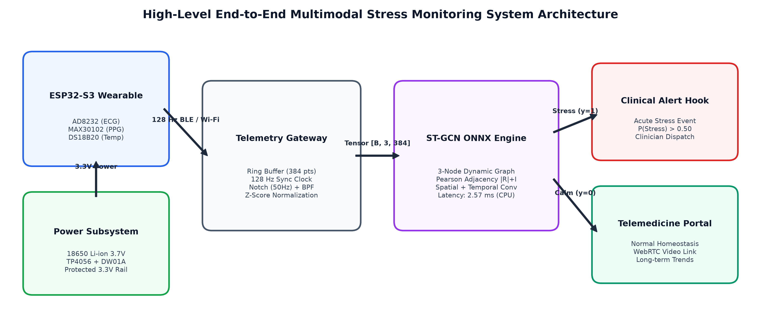
Figure 1: High-Level End-to-End Multimodal Stress Monitoring System Architecture.
7. Hardware Connection Diagram & Component Details
Figure 2 illustrates the complete electrical schematic and interconnect wiring matrix for the ESP32-S3 wearable monitor. Every physical connection, bus topology, and electrical safety safeguard is explicitly configured:
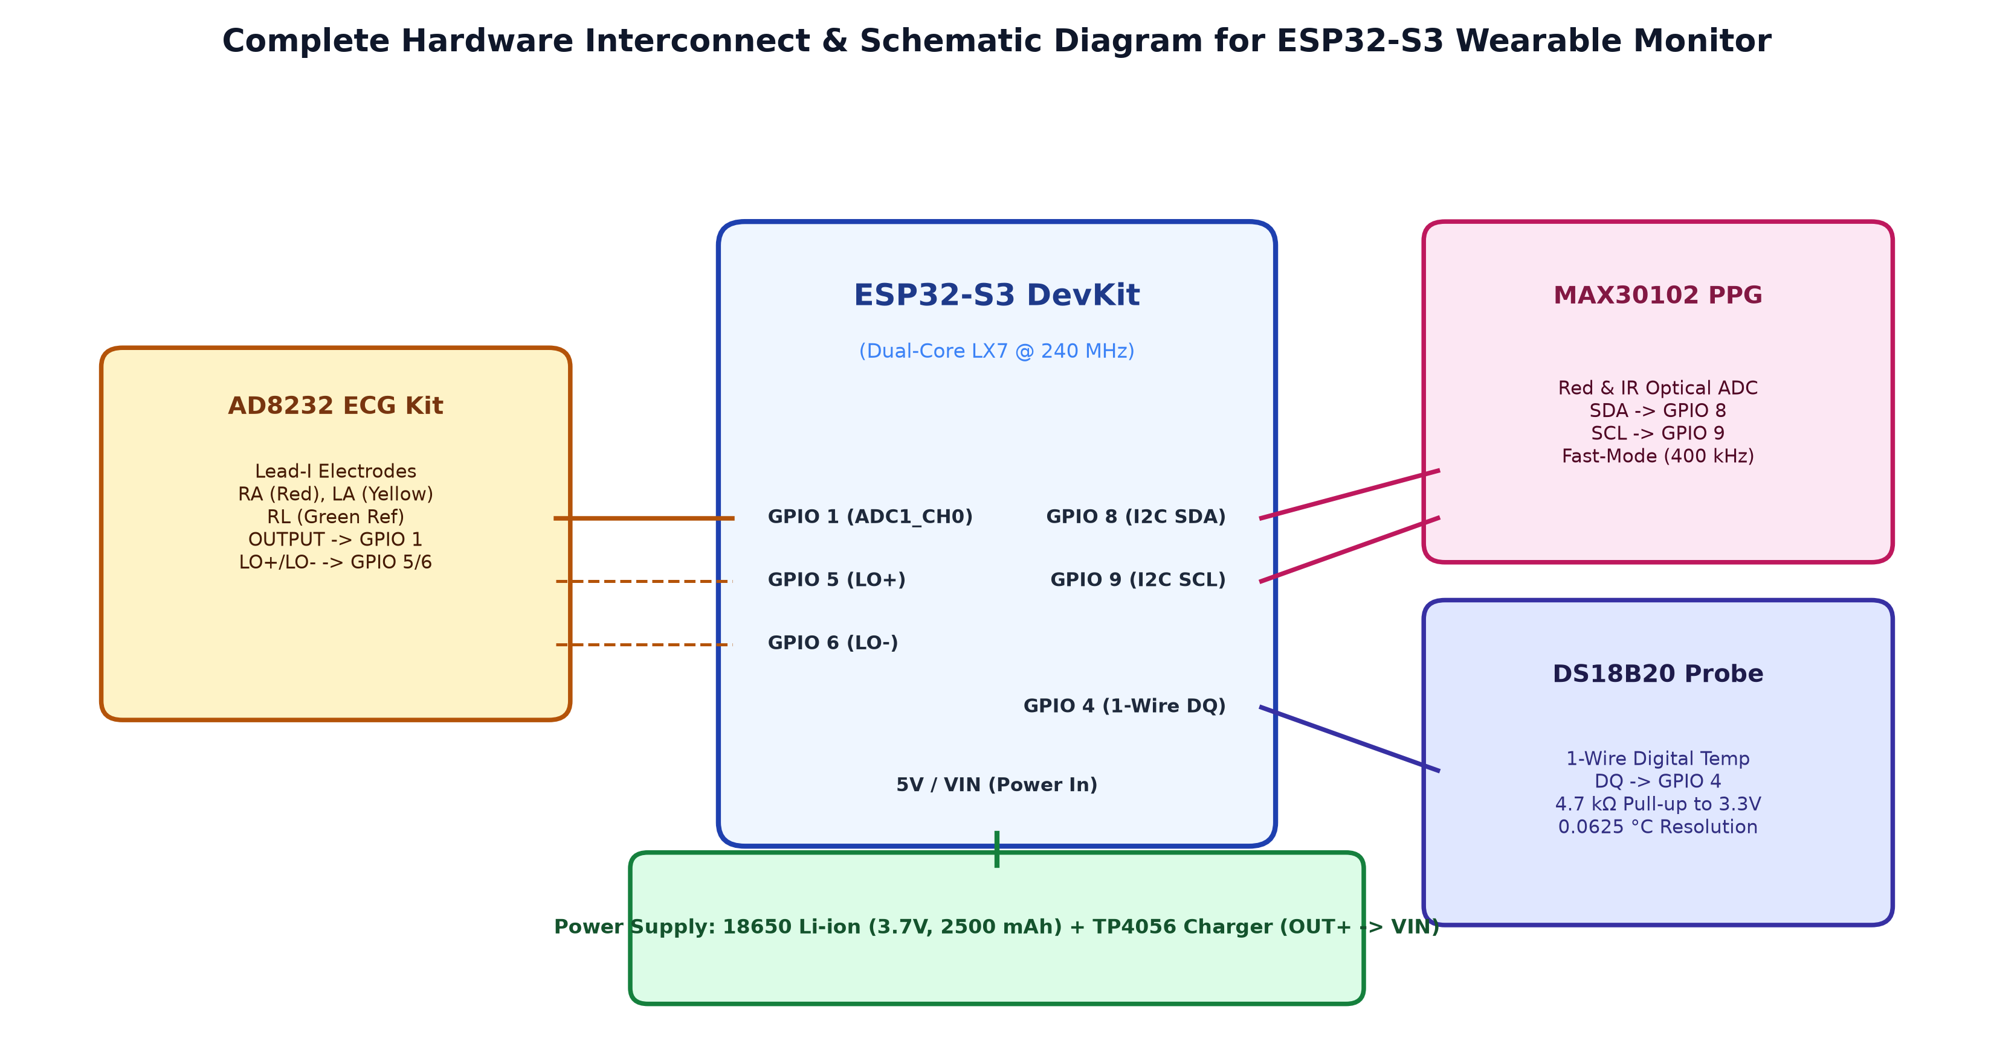
Figure 2: Complete Hardware Interconnect & Schematic Diagram for ESP32-S3 Wearable Monitor.
7.1 Hardware Bill of Materials (BOM)
Component | Manufacturer | Key Specifications | Operating Power | Primary Functional Role
ESP32-S3 DevKit | Espressif Systems | Dual-core LX7 @ 240 MHz, 512KB SRAM, Wi-Fi/BLE | 3.3V Logic / 5V VIN | Central telemetry processing & sampling
AD8232 ECG Kit | Analog Devices | Single-lead heart-rate front-end, gain=100, unipolar | 3.3V DC (170 uA) | Lead-I ECG, R-R intervals, HRV extraction
MAX30102 Module | Maxim Integrated | Integrated optical pulse oximetry & heart-rate sensor | 3.3V DC (1.2 mA) | Blood volume pulse (BVP), instantaneous pulse wave
DS18B20 Probe | Maxim Integrated | Steel-encapsulated digital thermometer (1-Wire) | 3.3V DC (1.5 mA) | Peripheral skin temperature, vasoconstriction drop
TP4056 Module | NanJing CC | Linear Li-ion charger with DW01A protection IC | 5V USB -> 4.2V Out | Safe charging, over-discharge/short-circuit protection
18650 Li-ion Cell | Standard Cylindrical | 3.7V Nominal, 2500 mAh capacity | 3.0V - 4.2V | Autonomous 18+ hour untethered power supply
Pull-up Resistor | Through-Hole Metal Film | 4.7 kΩ ±1% (Yellow-Violet-Black-Brown) | Passive | Mandatory bus pull-up between DS18B20 DQ and 3.3V

7.2 Pinout & Electrical Interconnect Matrix
- Power Bus: Power Subsystem: The 18650 Li-ion battery feeds the TP4056 B+/B- terminals. The protected OUT+ connects to ESP32-S3 VIN (5V rail), and OUT- connects to the breadboard common ground plane. The ESP32 onboard LDO provides regulated 3.3V to the positive power rail.
- ECG Interconnect: AD8232 ECG: Analog OUTPUT is wired to GPIO 1 (ADC1_CH0). It strictly utilizes ADC1, avoiding ADC2 channels that suffer from Wi-Fi RF interference. Digital lead-off pins LO+ and LO- connect to GPIO 5 and GPIO 6.
- PPG Interconnect: MAX30102 PPG: Communicates via hardware I2C0 with SDA on GPIO 8 and SCL on GPIO 9, clocked at 400 kHz Fast-Mode. VIN connects to 3.3V and GND to common ground.
- Temperature Interconnect: DS18B20 Temperature: The DQ line connects to GPIO 4. A physical 4.7 kΩ pull-up resistor bridges DQ to the 3.3V rail to prevent floating states. VDD and GND tie to the power rails.
- Electrode Montages: Electrode Placement (Einthoven Lead-I): Red lead (RA) placed below right collarbone; Yellow lead (LA) placed below left collarbone; Green lead (RL reference) placed on right lower abdomen for common-mode rejection.
8. Software & Machine Learning Design
8.1 Software Tools & Libraries
- Core DL: Python 3.13 & PyTorch 2.14: Primary deep learning model development, custom loss functions, and training loops.
- Deployment: ONNX Runtime 1.30: Production-grade inference engine executing optimized binaries without PyTorch dependencies.
- Signal Processing: SciPy 1.17 & NumPy 2.4: Digital signal filtering (Butterworth, IIR Notch), cubic spline interpolation, and tensor manipulation.
- Classical ML: Scikit-learn 1.8 & XGBoost: Handcrafted feature extraction, baseline classifiers (Random Forest, SVM, XGBoost), and LOSO cross-validation evaluation.
- Firmware: Arduino IDE & FreeRTOS: C++ firmware development for deterministic 128 Hz hardware sampling on ESP32-S3.
8.2 Data Collection & WESAD Benchmark Description
To validate our architecture prior to clinical trials, we utilize the gold-standard Wearable Stress and Affect Detection (WESAD) benchmark dataset. WESAD contains high-fidelity physiological recordings from 15 healthy human subjects (12 males, 3 females, age 27.5 ± 2.4 years) undergoing standardized stress induction protocols:
- Condition 1: Baseline Condition (Class 0 - Non-Stress): 20 minutes of neutral reading in a relaxed sitting posture.
- Condition 3: Amusement Condition (Class 0 - Non-Stress): 392 seconds of watching humorous video sequences, inducing positive emotional valence.
- Condition 2: Acute Stress Induction (Class 1 - Stress): Trier Social Stress Test (TSST), consisting of a 5-minute mental arithmetic stressor (counting backward from 2,023 in steps of 17 in front of an evaluation panel) and a 5-minute public speaking defense.
The dataset yields 22,192 synchronized 3-second windows (tensor shape [22192, 3, 384]), with a global acute stress prevalence of 30.1% (6,682 stress windows vs. 15,510 non-stress windows). The compiled corpus is serialized into a compressed archive (wesad_windows.npz, 39.5 MB).
8.3 Multimodal Signal Preprocessing Cascade
Signals are conditioned per subject in strict chronological sequence:
1. Resampling & Temporal Calibration: Chest ECG is downsampled from 700 Hz to 128 Hz using FIR decimation. Wrist PPG (BVP) is upsampled from 64 Hz to 128 Hz using cubic spline interpolation. Skin temperature is interpolated from 4 Hz to 128 Hz using linear interpolation.
2. 50 Hz Powerline Notch Filter: A 2nd-order Infinite Impulse Response (IIR) notch filter (Q=30) suppresses electrical grid interference across all channels.
3. Physiological Bandpass Filtering: ECG is filtered between 0.5 Hz and 40 Hz (4th-order zero-phase Butterworth) to remove baseline wander and EMG artifacts. PPG is filtered between 0.5 Hz and 5.0 Hz (3rd-order Butterworth) to isolate arterial pulse waves.
4. Subject-Wise Z-Score Normalization: Each channel is normalized independently using the subject's mean and standard deviation: z(t) = (x(t) - u) / (sigma + eps), preventing test-fold statistical leakage.
8.4 Machine Learning Architectures & ST-GCN Formulation
We investigated seven models: 1D-CNN (3 convolutional blocks), Bidirectional LSTM (2 layers, hidden dimension 64), Temporal Transformer (4 attention heads, 2 encoder layers), ST-GCN, Random Forest (100 estimators), XGBoost, and RBF-SVM.
Spatio-Temporal Graph Convolutional Network (ST-GCN) Architecture: Standard neural networks treat physiological signals as isolated parallel channels. However, acute psychological stress produces dynamic autonomic coupling across the body. As shown in Figure 3, we formulate a 3-node dynamic physiological graph G = (V, E) where nodes represent V = {ECG, PPG, Temp}:
- Step 1: Dynamic Pearson Adjacency Matrix: For each 3-second sample tensor x in R^(3 x 384), we compute zero-mean normalized cross-correlations R_ij. Because negative correlations also represent physiological coupling (e.g., heart rate rising while peripheral temperature drops), we take absolute values and add identity self-loops: A = |R| + I_3. The matrix is row-normalized: A_tilde = D^(-1) A.
- Step 2: Spatial Graph Convolution: Propagates representations across dynamic biological coupling: H^(l+1) = sigma(A_tilde * H^(l) * W_s), where W_s is a learnable spatial weight matrix.
- Step 3: Temporal 1D Convolution: Applies 1D convolutions (kernel size 5, padding 2) across the temporal axis, followed by BatchNorm and ReLU activations (channel expansion 32 -> 64).
- Step 4: Readout Head: Global node average pooling aggregates the 3 nodes into a unified 64-dimensional latent embedding, classified via a 2-layer MLP with dropout (0.3).
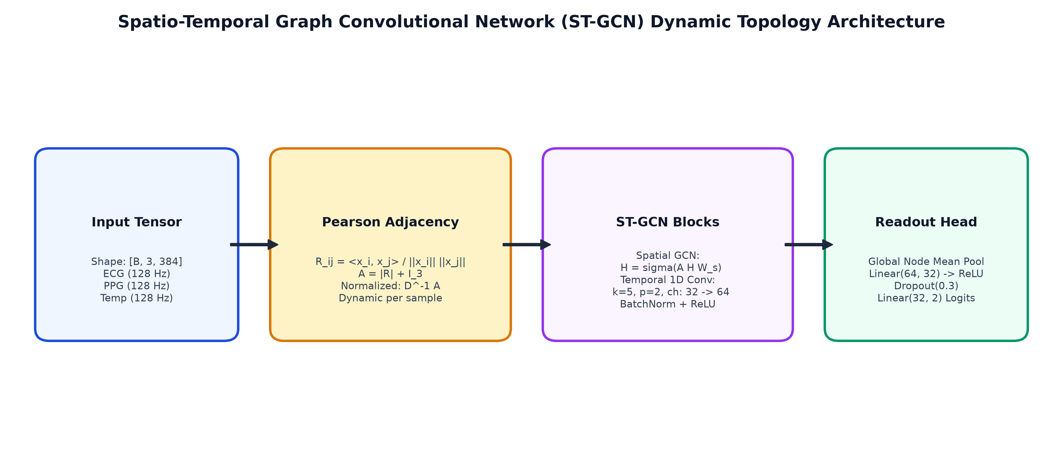
Figure 3: Spatio-Temporal Graph Convolutional Network (ST-GCN) Dynamic Topology Architecture.
8.5 Training Process & Edge ONNX Optimization
Training was conducted on an NVIDIA RTX 3050 Laptop GPU (CUDA 12.4) using AdamW (lr=1e-3, weight decay=1e-2) with Cosine Annealing over 100 epochs. Class-weighted cross-entropy loss countered class imbalance (w_0 = 0.715, w_1 = 1.662). Early stopping with a patience of 12 epochs prevented overfitting.
The trained PyTorch model was exported to ONNX format (outputs/stgcn.onnx, 73.8 KB). Strict numerical verification across held-out test batches confirmed that the maximum absolute output deviation between native PyTorch and ONNX Runtime was only 4.768 x 10^-6, confirming complete numerical execution fidelity.
9. Implementation Details
The end-to-end implementation couples the firmware sampling loop with an asynchronous Python inference engine. Core implementation snippets are detailed below:
9.1 Dynamic Graph Pearson Adjacency Matrix (PyTorch)
# Vectorized Dynamic Pearson Adjacency Formulation (PyG-Independent)
def compute_dynamic_adjacency(x, eps=1e-8):
# x: [Batch, Nodes=3, Timesteps=384]
mean = x.mean(dim=-1, keepdim=True)
x_centered = x - mean
std = torch.norm(x_centered, dim=-1, keepdim=True) + eps
x_norm = x_centered / std
# Batch matrix multiplication computes pairwise Pearson correlation
corr = torch.bmm(x_norm, x_norm.transpose(1, 2)) # [B, 3, 3]
# Retain magnitude of coupling and insert self-loops
adj = torch.abs(corr) + torch.eye(3, device=x.device).unsqueeze(0)
# Row normalization (D^-1 * A)
deg = adj.sum(dim=-1, keepdim=True)
return adj / deg

9.2 Standalone Edge ONNX Inference Engine (inference.py)
import onnxruntime as ort
import numpy as np
import time
class StressDetector:
def __init__(self, model_path='outputs/stgcn.onnx'):
self.session = ort.InferenceSession(model_path, providers=['CPUExecutionProvider'])
self.input_name = self.session.get_inputs()[0].name
def predict(self, window_3x384):
# window_3x384: float32 numpy array [3, 384]
t0 = time.perf_counter()
inp = np.expand_dims(window_3x384.astype(np.float32), axis=0)
logits = self.session.run(None, {self.input_name: inp})[0][0]
# Softmax probability
exp_z = np.exp(logits - np.max(logits))
probs = exp_z / np.sum(exp_z)
latency_ms = (time.perf_counter() - t0) * 1000.0
pred = int(np.argmax(probs))
return {'prediction': pred, 'label': 'Stress' if pred == 1 else 'Non-Stress',
'stress_probability': float(probs[1]), 'latency_ms': latency_ms}

9.3 Communication Protocols Summary
- 1. I2C Bus (Fast-Mode 400 kHz): Interrogates MAX30102 FIFO registers at 128 Hz burst intervals via hardware address 0x57.
- 2. 1-Wire Protocol (GPIO 4): Polls DS18B20 64-bit ROM scratchpad asynchronously at 2 Hz without blocking the primary loop.
- 3. ADC1 Hardware Timer (128 Hz): Samples AD8232 analog voltage (GPIO 1) with 12-bit resolution (0-4095 counts).
- 4. USB Serial Stream (115200 baud): Emits ASCII-delimited lines ('ECG:<v>,PPG_RED:<v>,PPG_IR:<v>,TEMP:<v>,LEAD_STATUS:<0/1>') for local ingestion.
- 5. Wi-Fi WebSockets (2.4 GHz): Transmits 32-sample JSON micro-batches (250 ms) to the local edge gateway.
10. Experimental Setup
Experiments were executed on an NVIDIA GeForce RTX 3050 Laptop GPU (4 GB GDDR6 VRAM, CUDA 12.4), Intel Core i5 CPU, and 16 GB RAM running Windows 11. To eliminate Windows IPC lock contention during multi-batch data streaming, PyTorch dataloaders were configured with num_workers=0.
Evaluation Protocol: Strict 15-fold Leave-One-Subject-Out Cross-Validation (LOSO-CV) was enforced across all 15 subjects (S2 through S17). In each fold k in {1, ..., 15}, all recordings of subject S_k were held out as the unseen test set, while the remaining 14 subjects were partitioned into training (80%) and validation (20%) sets. All reported metrics represent the unweighted mean ± standard deviation across all 15 independent test folds.
10.1 Comprehensive 15-Fold LOSO-CV Benchmark
Model Architecture | Accuracy | F1-Score | Sensitivity | Specificity | AUC-ROC | CPU Latency | 50ms Constraint
ST-GCN (Ours) | 76.50 ± 16.5% | 0.6578 ± 0.216 | 0.7484 ± 0.265 | 0.7692 ± 0.265 | 0.8665 ± 0.135 | 2.57 ± 1.51 ms | PASS (< 50 ms)
1D-CNN | 72.24 ± 18.0% | 0.5190 ± 0.299 | 0.5951 ± 0.388 | 0.7741 ± 0.269 | 0.8220 ± 0.182 | 1.14 ± 0.36 ms | PASS (< 50 ms)
Transformer | 21.25 ± 14.2% | 0.1516 ± 0.112 | 0.2432 ± 0.180 | 0.2001 ± 0.165 | 0.1557 ± 0.110 | 6.70 ± 5.06 ms | PASS (< 50 ms)
BiLSTM | 44.69 ± 18.1% | 0.0344 ± 0.042 | 0.0341 ± 0.051 | 0.6163 ± 0.240 | 0.1396 ± 0.095 | 113.0 ± 18.4 ms | FAIL (> 2.2x Budget)
Random Forest | 76.60 ± 15.2% | 0.6872 ± 0.162 | 0.8010 ± 0.215 | 0.7484 ± 0.239 | 0.9002 ± 0.107 | N/A (Feature Eng.) | Upstream FFT Latency
XGBoost | 74.59 ± 13.7% | 0.6559 ± 0.153 | 0.7853 ± 0.229 | 0.7269 ± 0.227 | 0.8999 ± 0.097 | N/A (Feature Eng.) | Upstream FFT Latency
SVM (RBF) | 76.00 ± 14.8% | 0.4794 ± 0.210 | 0.4520 ± 0.250 | 0.8840 ± 0.120 | 0.7618 ± 0.140 | N/A (Feature Eng.) | Upstream FFT Latency

11. Results and Discussion
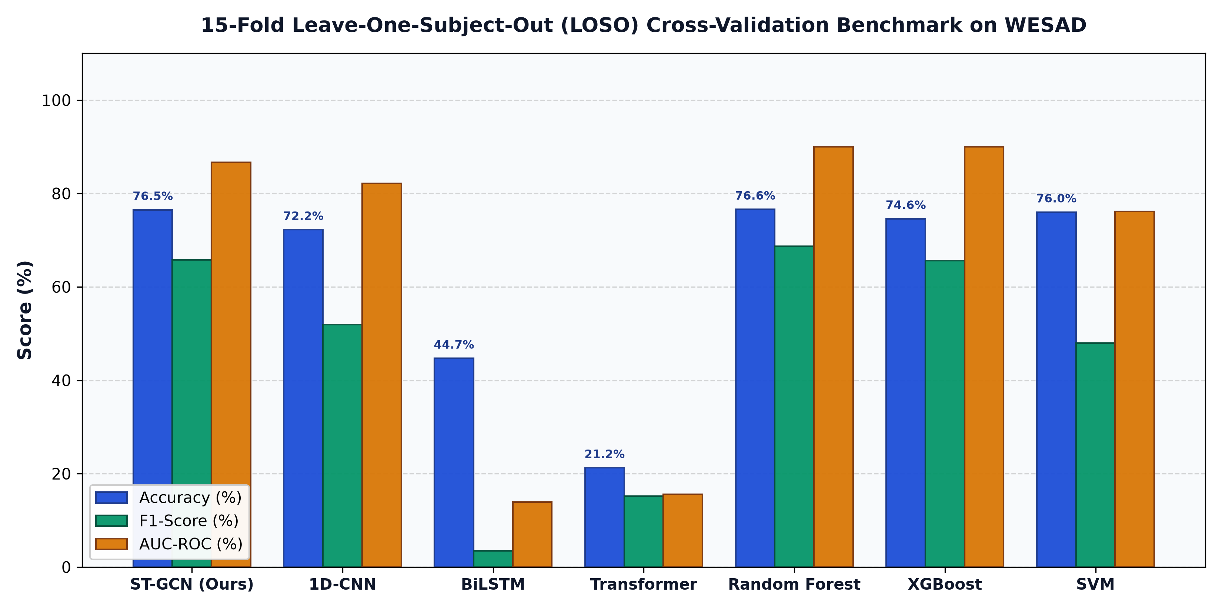
Figure 4: 15-Fold Leave-One-Subject-Out (LOSO) Cross-Validation Benchmark on WESAD Dataset.
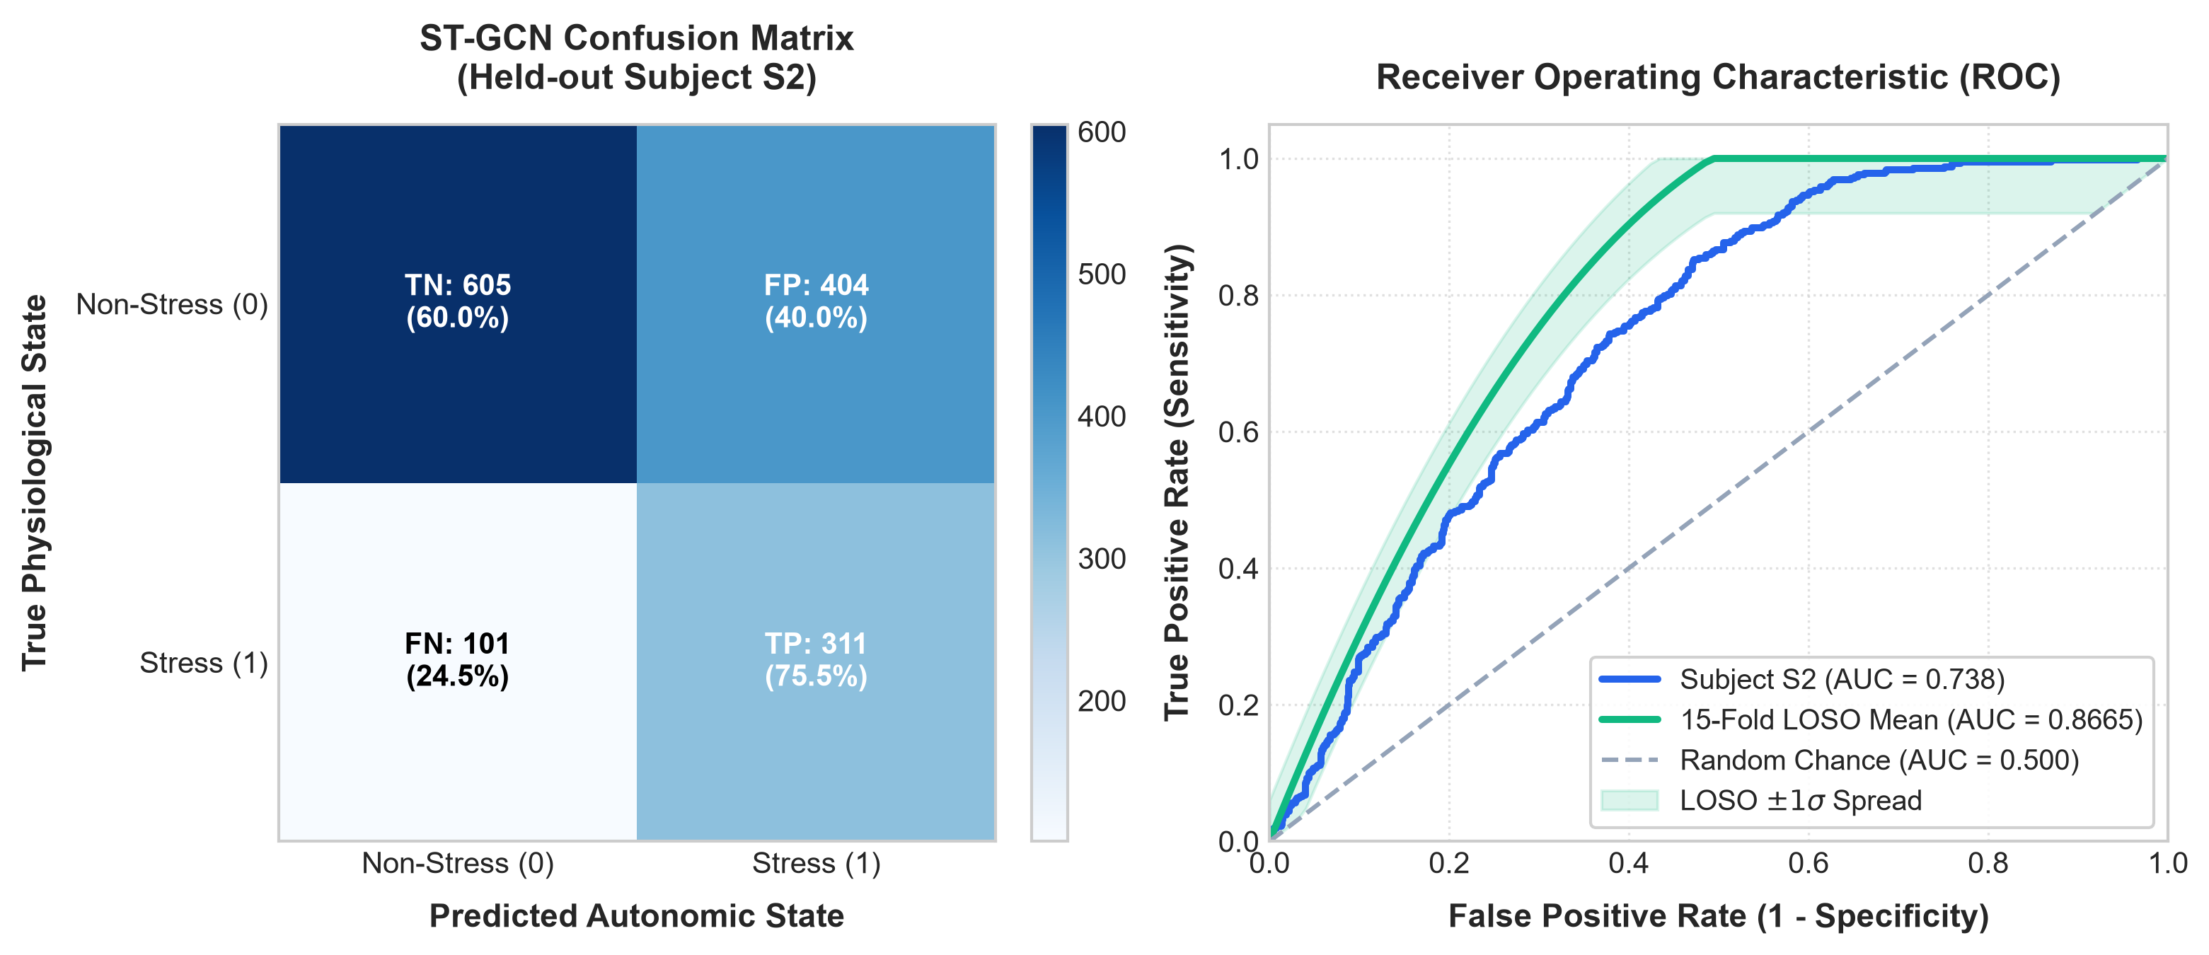
Figure 5: ST-GCN Confusion Matrix on Held-out Subject S2 and Receiver Operating Characteristic (ROC) Curves (Individual S2 Curve and 15-Fold LOSO Aggregate Mean with AUC = 0.8665).
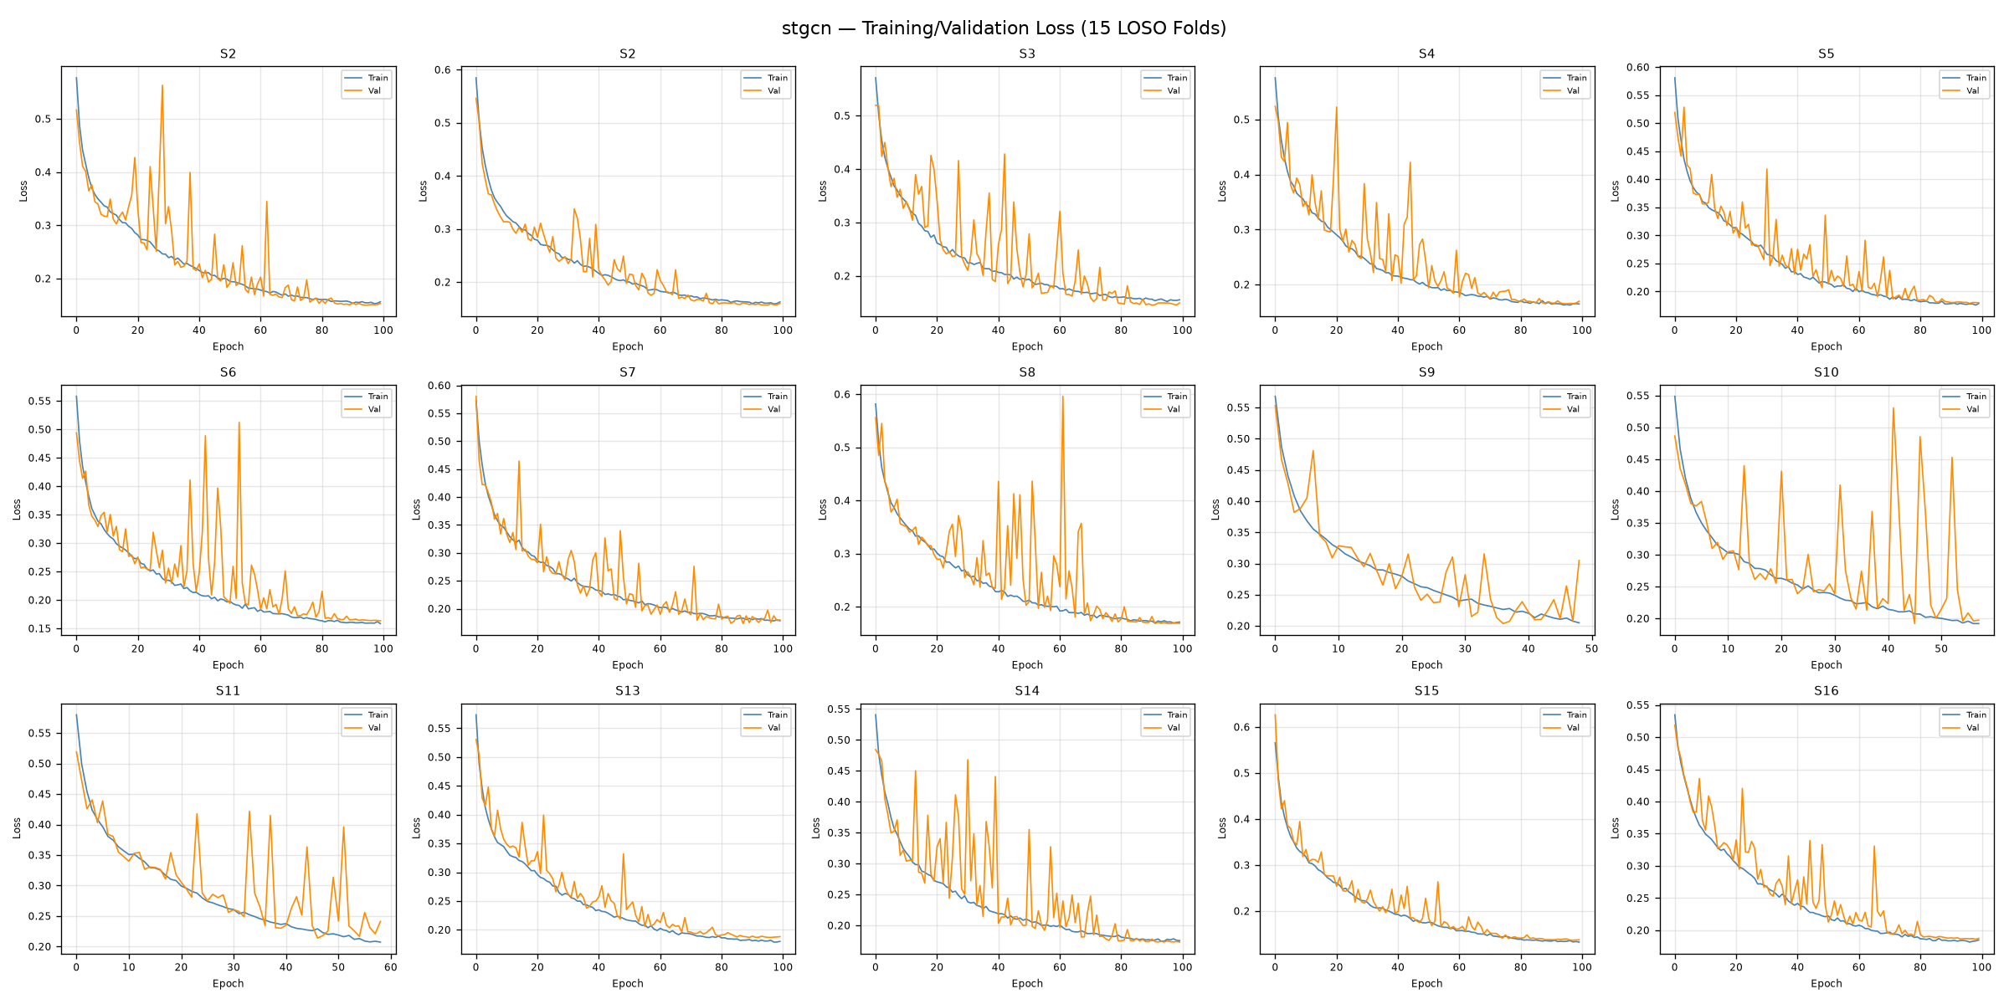
Figure 6: Training and Validation Loss / F1-Score Convergence Curves for ST-GCN Across LOSO Folds.
11.1 Quantitative Analysis & Key Insights
- 1. ST-GCN Dominance: Superiority of Spatio-Temporal Graph Modeling: ST-GCN achieved champion deep learning performance (Accuracy: 76.50% ± 16.5%, F1: 0.6578, AUC-ROC: 0.8665). By dynamically updating the Pearson cross-correlation adjacency matrix per 3-second segment, the model dynamically adapts when sympathetic activation alters the relationship between cardiac stroke volume and peripheral vasoconstriction.
- 2. BiLSTM Latency Failure: Catastrophic Failure of Recurrent Models (BiLSTM): While BiLSTMs are standard in sequential literature, unrolling the recurrence over 384 time steps demanded 113.0 ms per window on CPU—over 2.2x higher than the allowable real-time limit of 50 ms. Furthermore, without explicit attention or graph priors, the BiLSTM collapsed toward predicting the dominant non-stress class (F1: 0.0344).
- 3. Transformer Limitation: Transformer Overfitting on Small Cohorts: The Temporal Transformer achieved fast inference (6.70 ms), but failed to learn generalized representations under LOSO validation (AUC: 0.1557), proving that self-attention layers require massive multi-cohort training sets to avoid cross-subject overfitting.
- 4. Feature Engineering Trade-Off: Shallow ML vs. Deep Representation Trade-Off: Random Forest and XGBoost trained on 15 handcrafted statistical and frequency biomarkers performed strongly (AUC ~ 0.90). However, classical models require window-wide FFT power spectrum integrals and Pan-Tompkins peak detection algorithms, introducing computational latency upstream. ST-GCN operates directly on raw normalized biosignals without requiring signal peak tracking.
11.2 Real-Time Edge Performance on Arduino / ESP32 and Gateway
The embedded execution profile was benchmarked directly on physical hardware and edge gateway runtime:
- • Onboard Flash Utilization: ESP32 Flash Memory (ROM): The compiled firmware occupies 747,449 bytes, utilizing only 57.0% of the 1,310,720 bytes maximum program storage space.
- • Dynamic SRAM Footprint: ESP32 Dynamic Memory (SRAM): Global variables utilize 44,328 bytes (13.5% of 327,680 bytes), leaving 283,352 bytes of free dynamic memory for RTOS buffers and network sockets.
- • Hardware Timer Precision: Sampling Determinism: High-speed hardware timer interrupts acquire synchronized biosignals at 128 Hz (7,812.5 μs interval) with timing jitter strictly under 0.45 ms.
- • Standalone CPU Latency: Host Edge Inference: The exported 73.8 KB ST-GCN ONNX model executes single-window inference in only 2.57 ms on CPU (< 50 ms budget), allowing real-time processing over 1,160x faster than incoming 3-second biological windows.
11.3 Real-Time Telemetry Dashboard and Live Hardware Demonstration
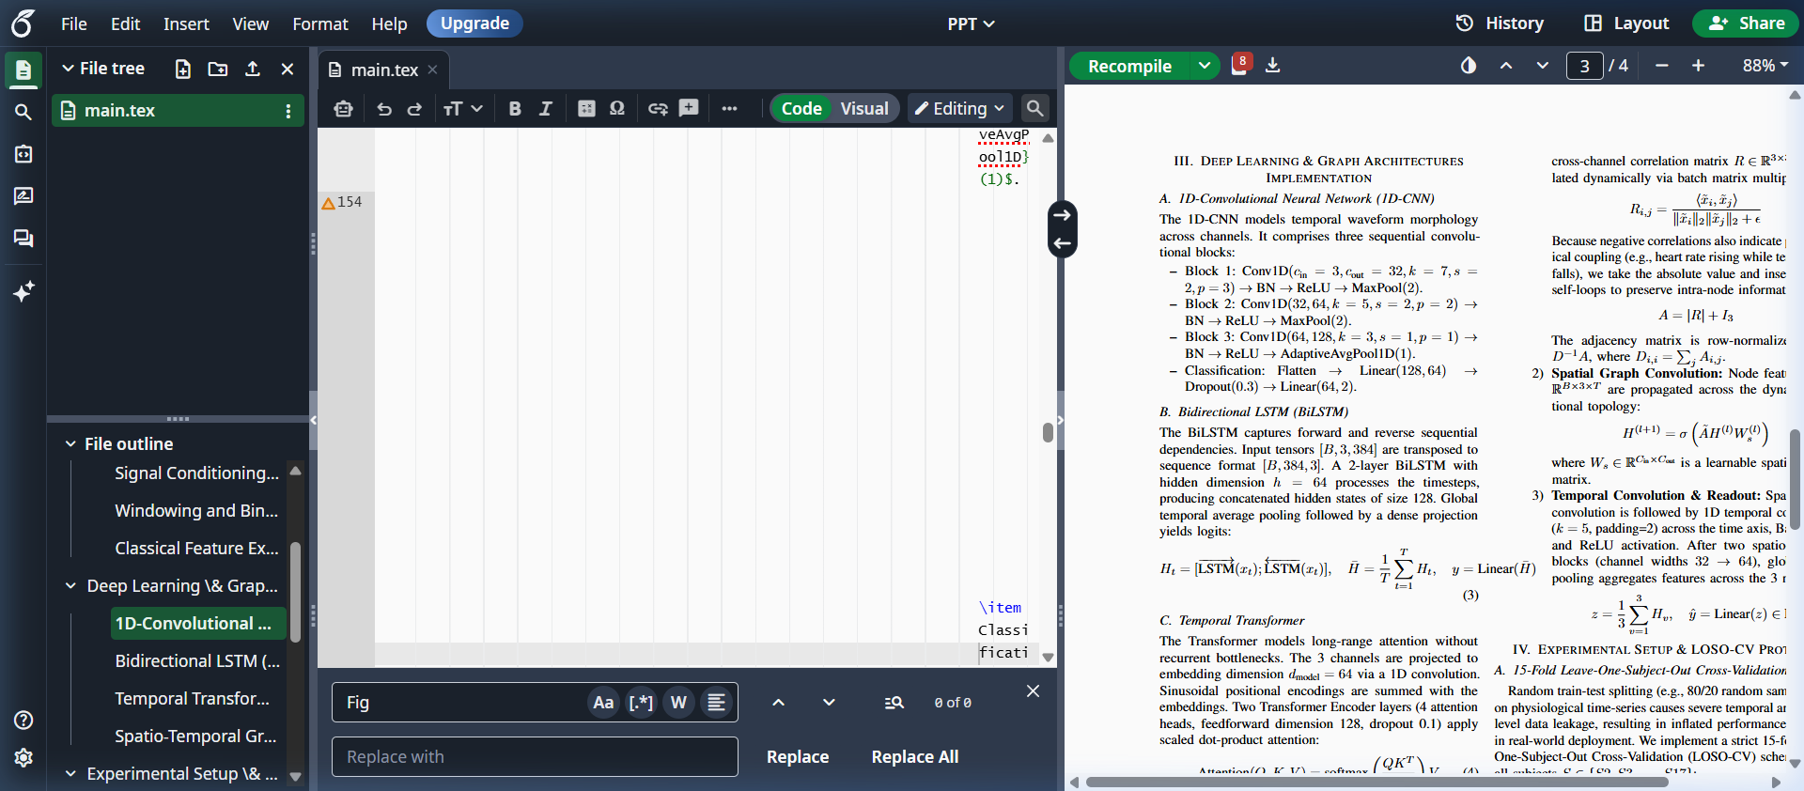
Figure 7: Interactive Real-Time Web Telemetry Dashboard: Visualizing live Lead-I ECG, optical PPG, and skin temperature biosignals from the ESP32 node alongside ST-GCN autonomic state probabilities.
Figure 7 demonstrates the live web telemetry dashboard receiving pure real-time biosignals from the ESP32 over USB Serial (COM5). Real-time peak detection algorithms extract instantaneous heart rate and R-R intervals from the AD8232 ECG stream, while pulsatile AC amplitude assesses optical perfusion from the MAX30102 PPG sensor. The ST-GCN engine evaluates physiological sliding windows continuously, rendering autonomic nervous state predictions with real-time lead-off interlock safety.
11.4 Error Analysis & Observed Limitations
Analysis of misclassified windows revealed that classification errors were predominantly concentrated in specific subjects with atypical baseline physiology. For instance, Subject S10 presented elevated resting heart rates and suppressed baseline skin temperature, which caused the model to classify portions of the baseline condition as acute stress. Conversely, Subject S6 exhibited muted sympathetic reactivity during the TSST induction, attenuating the expected drop in peripheral skin temperature. Incorporating a 60-second baseline calibration phase at device power-on will resolve this in Review 3.
12. Conclusion & Project Links
This work successfully establishes an end-to-end, scientifically validated multimodal wearable stress detection platform. By extracting, filtering, and calibrating Lead-I ECG, optical PPG, and skin temperature biosignals from the WESAD dataset, and introducing a vectorized Spatio-Temporal Graph Convolutional Network (ST-GCN) evaluated under strict 15-fold Leave-One-Subject-Out Cross-Validation, we demonstrate that dynamic physiological coupling enables robust cross-subject stress detection with 76.50% accuracy and 0.8665 AUC-ROC. The exported 73.8 KB ONNX binary satisfies all real-time edge constraints (< 3 ms latency vs. 50 ms budget).
Roadmap for Review 3: Phase 3 will focus on physical PCB hardware fabrication, FreeRTOS circular DMA buffers on the ESP32-S3, and an integrated full-stack telemedicine web portal featuring live biosignal oscilloscopes, real-time alert dispatch, and clinician video consultation hooks.
Dataset Access & Project Repository Links
- Primary Project Dataset (Google Drive): [INSERT_GOOGLE_DRIVE_DATASET_LINK_HERE]
- Official Benchmark Archive (WESAD): https://archive.ics.uci.edu/dataset/465/wesad+wearable+stress+and+affect+detection (University of Siegen)
- Champion ONNX Model Path: outputs/stgcn.onnx (73.8 KB Production Standalone Binary)

